LISTENING COMPREHENSION.

PART A.

You will hear 10 short conversations between two people. After each conversation you will hear a question. The conversations and the questions will not be repeated. After you hear the question, read the four possible answers and choose the best answer.
Now you have three minutes to look at the answers.

1.
(A) The man already used up all his vacation time.
(B) It’s a bad time of year to go sightseeing.
(C) The man should reconsider his decision.
(D) The man isn’t working hard enough.
2.
(A) She could not play racquetball because of an injury.
(B) She already played racquetball the other day.
(C) She thought the man had cancelled their racquetball game.
(D) She forgot about their plans to play racquetball.
3.
(A) The man’s artwork is superior to Theresa’s.
(B) The man shouldn’t be so competitive.
(C) The man should try harder to win.
(D) The man shouldn’t compare himself to Theresa.
4.
(A) Horror movies typically frighten her too much.
(B) She found the film more interesting than the man did.
(C) She was impressed by the acting in the movie.
(D) She doesn’t agree with the man’s opinion.

5.
(A) He’s probably seen the opera before.
(B) He should be able to buy tickets for the game.
(C) He intended to see the opera at another time.
(D) He probably isn’t interested in opera.
6.
(A) He switched jobs recently.
(B) He’s unhappy with his work.
(C) He feels he deserves some time off from work.
(0) He’s in a good mood because of his vacation.
7.
(A) He has only a week until he gets married.
(B) His wedding will take place out of town.
(C) He might not be able to attend the wedding.
(D) He’s been invited to another wedding.

8.
(A) She isn’t going anywhere during the vacation.
(B) She doesn’t think she passed her midterms.
(C) She doesn’t want to go to Florida with the man.
(D) She plans to study for her exams instead of traveling.
9.
(A) She is not very neat.
(B) She’s probably close by.
(C) She’s studying in the library.
(D) She called to say she’d be late.

10.
(A)He’d prefer to go later.
(B)He’d like to buy a sewing kit.
(C)He thinks the mall is already closed.
(D)He’d rather not go with her.

PART B.

In this part you will hear longer conversations. The conversations and the questions will not be repeated.
After you hear the question, read the four possible answers and choose the best answer.
Now you have two minutes to look at the answers.

31.
(A) The German language.
(B) A study program abroad.
(C) Traveling to Europe.
(D) The cost of financing an education.
32.
(A) Students will take a comprehensive test in German.
(B) A farewell party will be given.
(C) Students will travel throughout Germany.
(D) Final exams will be held.
33.
(A) It doesn’t require students to speak German in class.
(B) It doesn’t give him the chance to travel.
(C) He hasn’t studied German for very long.
(D) He doesn’t have the time to spend four weeks abroad.
34.
(A) Give the man a financial aid application.
(B) Tell him how much the summer program costs.
(C) Provide him with information on the Berlin program.
(D) Enroll in the summer program in Germany.

READING COMPREHENSION.

PART A.

Read questions 1-7. Find the answers in extracts A-H and put the correct letter in the box below the texts. There is one extra text. There is an example at the beginning (0).

SOME SPORTS
Decide which kind of sport allows:
0. To stake on the future results.
1. The players to touch the ball with his hands.
2. A single match to last for several days.
3. To kill animals.
4. To get players for money.
5. To have a different number of balls.
6. To use cinema houses for it.
7. To entertain students in summer.

A. Amateur cricket is played between club teams mainly on Sunday afternoons. Nearly every village has its cricket club. A first class match lasts for up to three days. The game is played between two teams, each of 11 people. The aim is to win a large number of runs.
B. Every large town has at least one professional football club, The players may not have any connections with the town for whose team they play. They are bought and sold with the agreement between the clubs. English football league is organized in four divisions with 22 or 24 teams in each.
C. Rugger is played with an egg-shaped ball which may be carried or thrown. If a player is carrying the ball he may be tackled or attacked and made to fall down. Each team has 15 players who spend much time lying in the mud and on top of each other.
D. The ancient game of bowls is played mainly by middle-aged people. In the game a heavy wooden ball (bowl) is rolled over a smooth lawn in such a way that it passes as close as possible to a small white ball (Jack). The game has from two to eight players, each bowling two or more bowls.
E. Another popular sport is horse- racing. There are many tracks all over the country. There are totalisators at the race-courses but bookmakers are also allowed to take bits before the end of the course. A famous race-course is located near Epsom. The event is named after the Earl of Derby who first organized such a race in 1780.
F. Another popular game is bingo or lotto which is usually played in halls or former cinemas. Players buy cards with rows of numbers and cross off the numbers as they are called out by a special announcer. The winner is the first player to cross out all the numbers on his card.
G. A very popular sport among the rich is fox-hunting. Specially trained hounds are brought to the place where the hunt starts. The horses too are brought in vans. The riders usually wear red coats. Having received permission from the local farmers the hunt for the fox starts.
H. Rowing occupies a leading place in the sporting life of schools and universities which have suitable water nearby. Several regattas held mainly in summer0 are watched from the river banks by large crowds of spectators.

0 | 1 | 2 | 3 | 4 | 5 | 6 | 7
E

PART B.

Read the text. Answer the questions to the texts choosing one of the given answers.

WHERE THERE’S A WILL

0. While leaving Dr. Meynell told Charles Ridgeway: “ Your aunt may live for years. At the same time any shock may kill her. She must lead a very quiet life. And she must be kept cheerful. Charles was a very thoughtful patient young man. He was also persistent. That evening he suggested the installation of a radio set. “My dear Aunt Mary,” said Charles enthusiastically, “it is the very thing for you to keep you cheerful. You will listen to different programmes, Berlin, for example.”
1. Mary Hurter, Charles’s aunt, was very fond of Charles. For some years a niece had lived with her and she had even thought of leaving her all her property and money. But her niece Miriam was impatient, bored by her aunt’s society and then married a man of whom her aunt disapproved. Thus Mrs. Hurter found nieces disappointing and turned her attention to nephews. Charles was a success. And she made a new will.
2. It was about 3 months after the radio had keen installed that a strange thing occurred. Charles was out that evening. Mrs. Harter was listening to one of her favourite operas when the music suddenly stopped and she heard a voice, a man’s voice with a faint Irish accent. “Mary — can you hear me? It’s Patrick speaking. I’m coming for you soon. You will be ready, won’t you, Mary?” Mary Barter was sure it was her dead husband’s voice. “1t’s a warning — that’s what it is,” she said to herself. She said nothing of her experience to anyone but she became thoughtful and preoccupied. And then came the second occasion. Mrs. Barter was sure it was no hallucination.
3. Friday evening found the house very quiet. Mrs. Barter sat as usual near the fireplace. All her preparations were made. She had written a list of instructions for Charles and had sent for her will. Now she was looking through the will again. Charles would be a very rich man after her death. Well, he had been a dear good boy for her.
4. It was half past nine. She switched on the radio. What would she hear? A familiar voice was announcing the weather forecast. Suddenly she heard a noise at the front door: her husband had come for her. The blue envelope with the will slipped into the fireplace as Mrs. Harter fell down to the ground. She was dead. When Charles came home late at night and learnt the news he looked very upset.
5. On the previous night when everybody was in bed Charles had removed a certain wire which ran from his room to his aunt’s. So as far as he could see he was perfectly safe. His plan had worked. Now he was to wait for the announcement of the will.
6. They couldn’t find the will anywhere in the house. Charles was shocked. “If that will’s never found, there’s a former will, dated September, 1920. By it Mrs. Barter left everything to her niece, Miriam Harter”, said the lawyer. Charles got pale. No hope in front of him — only the shadow of the prison wall for his debts.

0. The doctor said that Charles’s aunt _____
a. had a quiet life
b. could die of a shock because she was seriously ill
c. didn’t need a radio
d. could die of joy if he kept her cheerful

1. Mrs. Barter made a new will_____
a. in favour of her niece
b. because she wanted to give her money on charity
c. in favour of Charles because he was good and patient
d. because she was disappointed in all her relatives

2. Mary Barter became thoughtful because_____
a. she wanted to change the will
b. she wanted to find out who really talked to her
c. she didn’t hear the opera to the end
d. she believed her dead husband talked to her

3. Mary Harter made all preparations because she_____
a. was ready to die, following her husband
b. knew Charles would cheat everybody
c. wanted to destroy her will
d. wanted Miriam to be rich
4. The new will was burnt_____
a. because Mrs. Barter wanted to change It
b. because the house was set on fire
c. quite by chance
d. as the ghost of Mr. Barter threw it into the fire

5. Charles was sure that _____
a. his aunt had left all the money to Miriam
b. he had played a good trick
c. he had removed the wrong wire
d. he had missed the announcement of the will

6. Charles was unhappy because _____
a. he loved his aunt greatly
b. Miriam was poor
c. he could get imprisoned
d. the lawyer had divided the money between him and Miriam.

0 | 1 | 2 | 3 | 4 | 5 | 6
B

PART C.

Read the text. Answer the questions to the texts choosing one of the given answers.

Questions 1-12
Until about 75 years ago, the form of diabetes that usually strikes children and young adults was invariably lethal. Families and physicians watched helplessly as robust youngsters wasted away and died within weeks or months of diagnosis. By the early l900s investigators knew the problem lay with small clusters of pancreatic cells called the islets of Langerhans. It was evident these islets normally secreted a critical hormone, later named insulin, that enabled other cells to take up the sugar glucose from the blood for energy. It was also apparent that in the diabetic patients (today said to have type 1, or insulin- dependent, diabetes mellitus) insulin production had ceased. Consequently, glucose from food accumulated in the blood while other tissues starved. People with the more prevalent, later-onset form of diabetes—type II, or non-insulin-dependent—fared better because they continued to make at least some insulin.
Prospects for type I diabetics improved dramatically in the early 1920s, when insulin extracted from animals proved lifesaving. Indeed, for decades thereafter most people assumed daily injections of the hormone were tantamount to a cure. Sadly, they were mistaken. Over the years clinicians gradually came to realize that many patients eventually suffer from potentially devastating diabetes-related disorders. Microscopic blood vessels can slowly become damaged, often culminating in blindness or kidney failure, or both. Larger vessels may become prematurely narrowed by atherosclerosis, and nerves may be disrupted as well, leading to numbness and pain in the, extremities. The cause of these
“long-term complications” has now been shown to be excess glucose in the blood and the consequent alteration of tissues exposed to the extra sugar. Clearly, the insulin injections on which type I diabetics depend for survival cannot precisely mimic the ability of the normal pancreas to sense blood glucose levels and put out exactly the amount of insulin needed to keep the body healthy.
The key to ensuring long-term health, then, is to provide therapy that can maintain glucose values within normal limits at all times from the start of the disease. An ideal treatment would be implantation of islets, because functional islets would restore proper insulin production and, in theory, would have to be implanted only once; native islets survive for many years and carry within them the precursor cells needed to supply replacements for cells that die.

1. What is the main point of the passage?
(A) A long-term treatment for diabetes is yet to be found.
(B) They key to curing diabetes is the implantation of islets.
(C) The outlook for diabetics is a bleak one.
(D) Diabetics suffer because they cannot produce a necessary hormone.

2. According to the passage, what role does insulin play in the human body?
(A) It secretes a hormone that increases energy.
(B) It enables the islets to function properly.
(C) It allows cells to absorb glucose from the blood.
(D) It assists in the digestion of food.

3. The word “lethal” (“Until 75 years ago ...“) is closest in meaning to
(A) incurable
(B) extensive
(C) deadly
(D) inconsistent

4. The word “ceased” (“It was apparent that in ...“) is closest in meaning to
(A) improved
(B) halted
(C) deepened
(D) emerged

5. The word “they” (“People the more prevalent ...“) refers to
(A) tissues
(B) blood
(C) type I diabetics
(D) type II diabetics

6. According to the passage, what is one difference between people with type I diabetes and people with type II diabetes?
(A)Type I diabetics are more likely to die at a younger age.
(B)Type II diabetics have insufficient glucose in their blood.
(C)Type I diabetics are unable to produce insulin.
(D)Type II diabetics have been, for the most part, cured.

7. The passage suggests that type I diabetics today
(A) are often diagnosed improperly
(B) can live past childhood
(C) are incapable of leading normal lives
(D) are as healthy as people without diabetes
8. Which of the following is NOT mentioned as a long-term complication for type I diabetics?
(A) Atherosclerosis
(B) Numbness
(C) Kidney failure
(D) Anemia

9. The word “mimic” (“Clearly, the insulin injections ...“) is closest in meaning to
(A) imitate
(B) cooperate with
(C) distribute
(D) share
10. According to the passage, insulin injections are
(A) not entirely successful
(B) able to guarantee a diabetic’s health
(C) responsible for the excess glucose in the blood
(D) equal to pancreatic production of insulin

PRACTICAL USE OF ENGLISH.

PART A.
Read the text and fill in the blanks (1-20) choosing the correct variant below.

“I wish he 1_________ me know,” the young man said. “I wrote 2 ________ a letter saying that I 3__________ . I 4 _______ all this trouble 5_________nothing. Well, 6_________ he isn’t here, 7_________ no point in waiting.” He 8______ Mrs. Crump and 9__________. Mrs. Crum went 10_______to the window and watched 11________ off. When his car was out of sight, she called out: “You 12_________ out now, Mr. White. He 13__________.’’ Mr. White came out of the kitchen, where he 14_____________ . “Many thanks, Mrs. Crump,” he said, laughing. “You did that very well. These nephews of mine never 15___________ me 16_________ peace. That young man is 17_________ of them all. As you see, when he18______ money, he even 19______ me into the country. Well, perhaps next time he 20______ me by writing me a letter.

1. A. has let B. let C. have let D. had let
2. A. his B. him C. he D. himself
3. A. ’m coming B. will come C. was coming D. come
4. A. ’ve had B. have C. had had D. has
5. A. for B. as C. to D. of
6. A. because B. since C. so D. though
7. A. It is B. there is C. there was D. It was
8. A. thanked B. thanks C. thank D. ’s thanked
9. A. goes out B. go out C. ’s gone out D. went out
10. A. at B. on C. to D. from
11. A. he drive B. him drove C. him drive D. he drive
12. A, must to come B. might come C. can to come D. can come
13. A. ’s gone B. went C. was going D. gone
14. A. had been waiting B. was waiting C. has been waiting D. is waiting
15. A. gave B. gives C. give D. ’s given
16. A. no B. some C. the D. any
17. A. worse B. the worst C. most bad D. the most bad
18. A. needs B. need C. needed D.’ll need
19. A. follow B. followed C. follows D. ’ll follow
20. A. shan’t warn B. won’t warn C. isn’t going to warn D. Isn’t warning

PART B.

Change the words given in the box and find a proper place for them (1-10) in the text.

A TV in the bedroom and cash to spend.
MOST of today’s children have money in their pocket and television in the bedroom. They worry about the environment, prefer the toys their parents enjoyed, and stay away from church. Children’s spending (1__) is rising annually and this year average pocket money reached a record (2__) of $2 a week. For the first time in the 20 years in(3__) records have been kept, girls are getting slightly more than boys—5 cents a week on average.
However, particularly for older children, pocket money is not the (4__) source of income and a quarter of those over 11 have a(5__) of some kind. One 15-year-old in ten has at least $ 1000 a year to spend and (6__) than eight in ten have at least $ 5 a week.
Two out of five of those over ten have a building society account and a further third in the (7__) group have a bank account. National Savings are most common (8__) the teens. Homes with children also tend to be (9__) with consumer durables. Nine in ten children go home to a colour television, video, washing machine and freezer. Watching television is the favourite (10__), with the average child watching three hours a day.

Age, among, high, job, money, more, packed,

pastime, only, power, rich, which

PART C.

Complete the following sentences using one of the four phrases given below.

1 _____________ is a large sporting dog, similar in size and weight to an English setter but different in color.
(A) Like an Irish setter
(B) An Irish setter
(C) An Irish setter is what
(D) As an Irish setter

2. In 1979 Earvin “Magic” Johnson __________ basketball as a power forward
for the Los Angeles Lakers.
(A) begin to play professional
(B) beginning and playing professionally
(C) began playing professional
(D) to have begun playing professionally
3. Instead of giving birth to live young, the platypus lays eggs, a characteristic
which makes_____________ from other mammals.
(A) differently
(B) is differently
(C) it different
(D) it is different
4. Of all the monarchs in French history, the infamous Louis XVI is the one_______
(A) whom with the public is most familiar
(B) with whom the public is most familiar
(C) that the public is familiar the most
(D) the public is most familiar with him

5. The increasing use of the Internet as means to disseminate information has
become __________for many countries .
(A) the importance of a consideration
(B) a consideration of important
(C) the importance considering
(D) an important consideration

6. ___________________very large or very small numbers in compact form is called scientific notation.
(A) Expressing the means
(B) The means of expressing
(C) To mean expressively of
(D) That is the means of expression

7. Henry James’s novel Portrait of a Lady tells the story of a young woman who travels to Europe and finds herself transformed by the American expatriates ___________
(A) she associates with whom
(B) with whom she associates
(C) whom with she associates
(D) associates she whom with

8. __________________what caused the universe to evolve is debatable.
(A) Whether scientists can truly determine
(B) Can scientists truly determine
(C) Whether scientists can determine true
(D) Scientists can truly determine

9. Beloved, a novel about a woman, her living daughter, and her ghoust daughter, is one of Toni Morrison’s_________________ works.
(A) most memorable
(B) the most memorable
(C) are most memorable
(D) and most memorable

10. The Watergate scandal of 1972 had a dramatic impact on________________ people in the United States viewed the office of the presidency.
(A) it was the way
(B) being the way that
(C) which the way
(D) the way

11.Because vinegar is an acid and baking soda a base, the two produce a neutral solution___________.
(A) when mixed together
(B) when together are mixed
(C) together they are mixed
(D) mixed are they todether

12. __________________ a marsupial, an animal must not carry its young, while in embryonic form, in a true placenta but rather in a pouch.
(A) Considers
(B) The consideration
(C) To be considered
(D) for being considered

13. Steffi Graf is a unique athlete _____________is the only tennis player ever to win a “golden” Grand Slam.
(A) she
(B) in she
(C) that she
(D) in that she

14. In the sixteenth century, Martin Luther, _______________against what he saw as the spiritual laxity of the church, wrote his historic 95 theses.
(A) reacted
(B) was reacting
(C) reacting
(D) did react

15. A tapeworm, which can often reach ____________________in length, is a parasite that attaches itself to the intestinal wall of its host.
(A) or fifteen feet more
(B) or fifteen feet as
(C) at least the fifteen feet
(D) fifteen feet or more

WRITING PRACTICE.

PART A.

Fill in the card everyone has to fill on entering Malta.

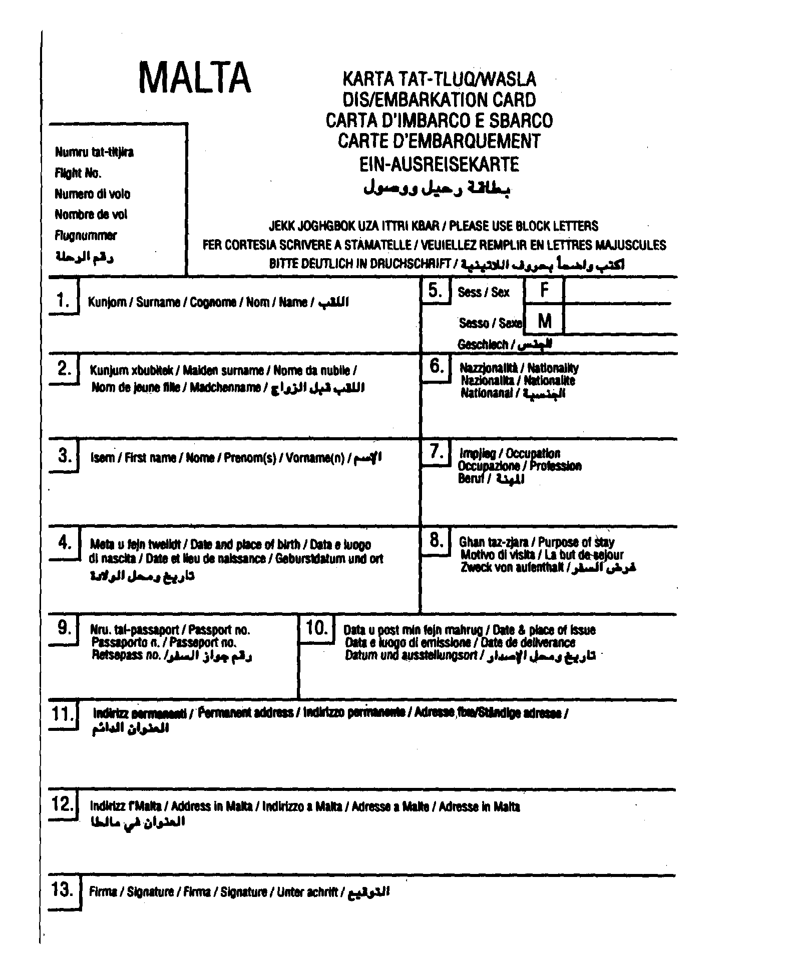

PART B.

Write an answer to the letter received through E-mail. Use about 160-200 words.

Dear friend,
My school holidays have just begun. I’m packing my bag because my family and I are leaving early tomorrow morning to go to the mountains. We go to the same place every winter and do a lot of downhill skiing. I just love it there. The hotel is nice, the food is not bad and, what is more important, I have a lot of good friends there—boys and girls of my age. I’m going to go to the disco in the evening and practice skiing in the day time.
What are you planning for your winter holidays?
Best wishes,
Voitek

TOPICS FOR ORAL COMPETITION.

1. What will you give your friend as a birthday present: a new CD, a white kitten, a box of chocolates? Comment on your choice.

2. After school you can continue education in Moscow, in Oxford, in an American business school. What will you choose and why?

3. Your school has passed over to the new system of education and you can now choose your main subject yourself. What will you choose and why?

4. Your parents have allowed you to travel together with your friend in summer. What places in our country will you choose? Why?

5. Your parents have allowed you to travel together with your friend in summer. What places abroad will you choose and why?

6. For your summer job you are offered three vacancies: a waiter at Mac Donald’s, a baby-sitter, a social worker. Which of them will you choose and why?

7. Your foreign friend is coming to you in summer. What excursion programme will you make for him/her?

8. Where would you prefer to go with your boy/girl friend on Sunday: to the disco, to the museum (which one) or just for a walk?

9. There are three sport programmes on TV at the same time: a football match, a figure-skating competition and a game of golf. Which will you watch and why?

10. To what concert will you go with greater pleasure: a symphony orchestra, jazz music or
a pop music concert? Why?

11. Which of the foreign languages is more important today: English, German or Japanese? Why?

12. There are three books to your choice: a historical novel, modern science-fiction and a detective story. What will you take for holiday reading? Why?

13. If you had a chance to visit Britain during one of the holidays which holiday will you choose: Christmas, Easter or Guy Fawkes Night?

14. Your friends have decided to see the New Year in together but your parents don’t let you go saying that New Year is traditionally a family holiday. What will you do?

15. If you had to choose the greatest person of the 20th century in Russia whom would you choose: V. I. Lenin, Alexander Solzhenitzin, Andrei Sakharov or some other person? Why?

